INDEXU 7
Recaptcha Integration

By Dody Rachmat W. (dodyrw@gmail.com)
August 27, 2011

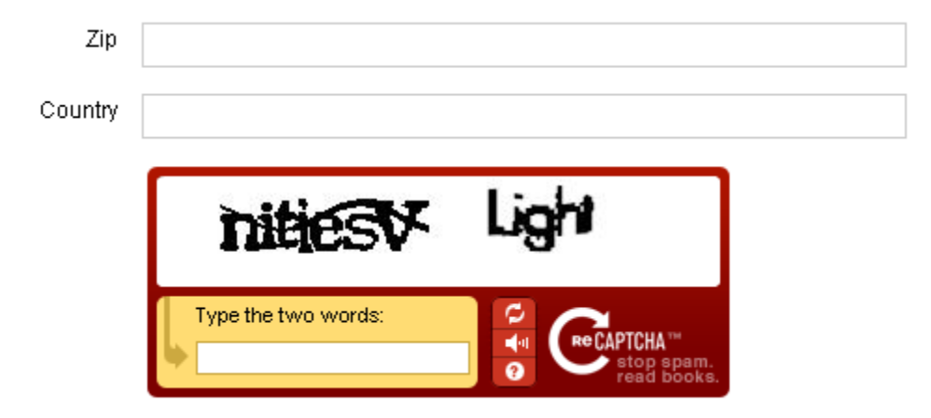

What is recaptcha? Here is the definition taken from recaptcha website.

reCAPTCHA is a free CAPTCHA service that helps to digitize books, newspapers and old time radio shows. Check out our paper in Science about it (or read more below).
A CAPTCHA is a program that can tell whether its user is a human or a computer. You've probably seen them — colorful images with distorted text at the bottom of Web registration forms. CAPTCHAs are used by many websites to prevent abuse from "bots," or automated programs usually written to generate spam. No computer program can read distorted text as well as humans can, so bots cannot navigate sites protected by CAPTCHAs.

By using recaptcha service, you strengthen your website against spammer and bots.

To get started, you need to get a pair of key from recaptcha website here :
http://www.google.com/recaptcha
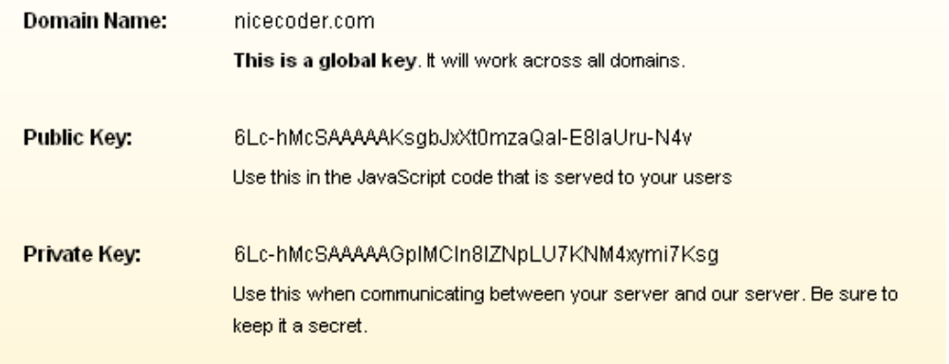
Enter the keys in Indexu admin panel.

Admin panel > 3rd Party > Recaptcha

